NEWS RELEASE

March 22, 2020

Data for County COVID-19 Cases Reported as of March 22 at 12 p.m.

Mecklenburg County, NC– On March 22, 2020 at 12 p.m. Mecklenburg County Public Health (MCPH) reported 80 positive cases of novel coronavirus (COVID-19) in the County. To help our community better understand how the pandemic is developing, below is data about the 80 positive cases that were reported. It is important to remember that this data is fluid and changes as the situation evolves.

Highlights of the data derived from the 80 positive COVID-19 cases reported in Mecklenburg County as of March 2, 2020 at 12 p.m. include:

- About half of reported cases were adults ages 20 to 39; one case was a youth under 19.
- The sex and racial/ethnic composition of reported cases were similar to the county demographics.
- Reported cases live throughout the county, with at least one case in nearly every zip code.

“I want to continue to encourage our community to follow the Public Health Orders that have been issued to help stop the spread of this disease in our community,” said Gibbie Harris, Mecklenburg County Public Health Director. “As the situation evolves, we will continue to provide more data and make decisions to protect the health of our residents.”

Additional data mapping for the 80 positive COVID-19 cases reported as of March 22, 2020 at 12 p.m.:

Total COVID-19 Cases Reported to MCHD by Date
(as of March 22, 2020 at 12PM)

Select Characteristics of COVID-19 Cases Reported to MCHD
(as of March 22, 2020 at 12PM)

 | Selected Characteristics | Percent of Confirmed COVID-19 Cases
Age | <20 | 1.2%
 | 20-39 | 48.8%
 | 40-59 | 32.5%
 | ≥ 60 | 17.5%
Sex | Female | 50.0%
 | Male | 50.0%
Race/Ethnicity | White | 43.8%
 | Black | 35.0%
 | Hispanic | 3.8%
 | Asian | 2.5%
 | Alaskan Native/American Indian | 1.2%
 | Other/Not Reported | 13.7%

Distribution of COVID-19 Cases Reported to MCHD by Zip Code of Patient’s Residence
(as of March 22, 2020 at 12 p.m.)
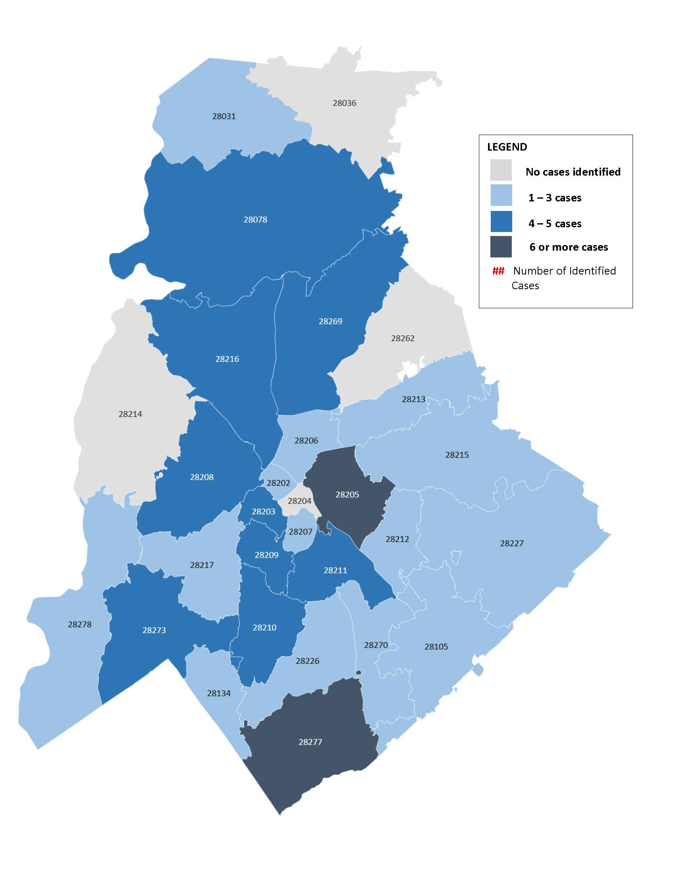
It is important to make sure the information you are getting about COVID-19 is coming directly from reliable sources like MCPH, CDC and NCDHHS. The best resource for information about COVID-19 in Mecklenburg County is the County’s website, MeckNC.gov. Individuals can also call the County’s COVID-19 hotline at 980-314-9400.
For more information, please visit the County’s website, MeckNC.gov, the CDC’s website at www.cdc.gov/coronavirus and NCDHHS’ website at www.ncdhhs.gov/coronavirus, which will also include future positive COVID-19 test results in North Carolina.
*There will be a Media Availability Monday, March 23 at 1 p.m. via livestream for more information or questions. More information to come on accessing the livestream.
# # #

Media Contact: Rebecca Carter, Public Information Officer, 704-301-7618 Rebecca.Carter@mecklenburgcountync.gov

