Private Film Screening
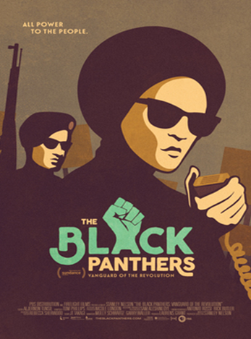

The Black Panthers: Vanguard of the Revolution

When: Thursday, December 03
Time: 7:30PM - 9:56PM
Where: AMC Concord Mills 24
8422 Concord Mills Blvd, Concord, NC, 28027
Cost: $12.00 Q & A to follow
Purchase Tickets at: https://www.tugg.com/events/76601.
Promoted by Leavy Forte
(Nephew of Founding Black Panthers Sherman & Reggie Forte)
Deadline to purchase tickets: November 26
THE BLACK PANTHERS: VANGUARD OF THE REVOLUTION is the first feature length documentary to explore the Black Panther Party, its significance to the broader American culture, its cultural and political awakening for black people, and the painful lessons wrought when a movement derails. Master documentarian Stanley Nelson goes straight to the source, weaving a treasure trove of rare archival footage with the voices of the people who were there: police, FBI informants, journalists, white supporters and detractors, and Black Panthers who remained loyal to the party and those who left it. Featuring Kathleen Cleaver, Jamal Joseph, and
many others, THE BLACK PANTHERS: VANGUARD OF THE REVOLUTION is an essential history and a vibrant chronicle of this pivotal movement that birthed a new revolutionary culture in America.
Locally Sponsored By:
SAFE Coalition NC, Charlotte / Mecklenburg NAACP & Action NC

