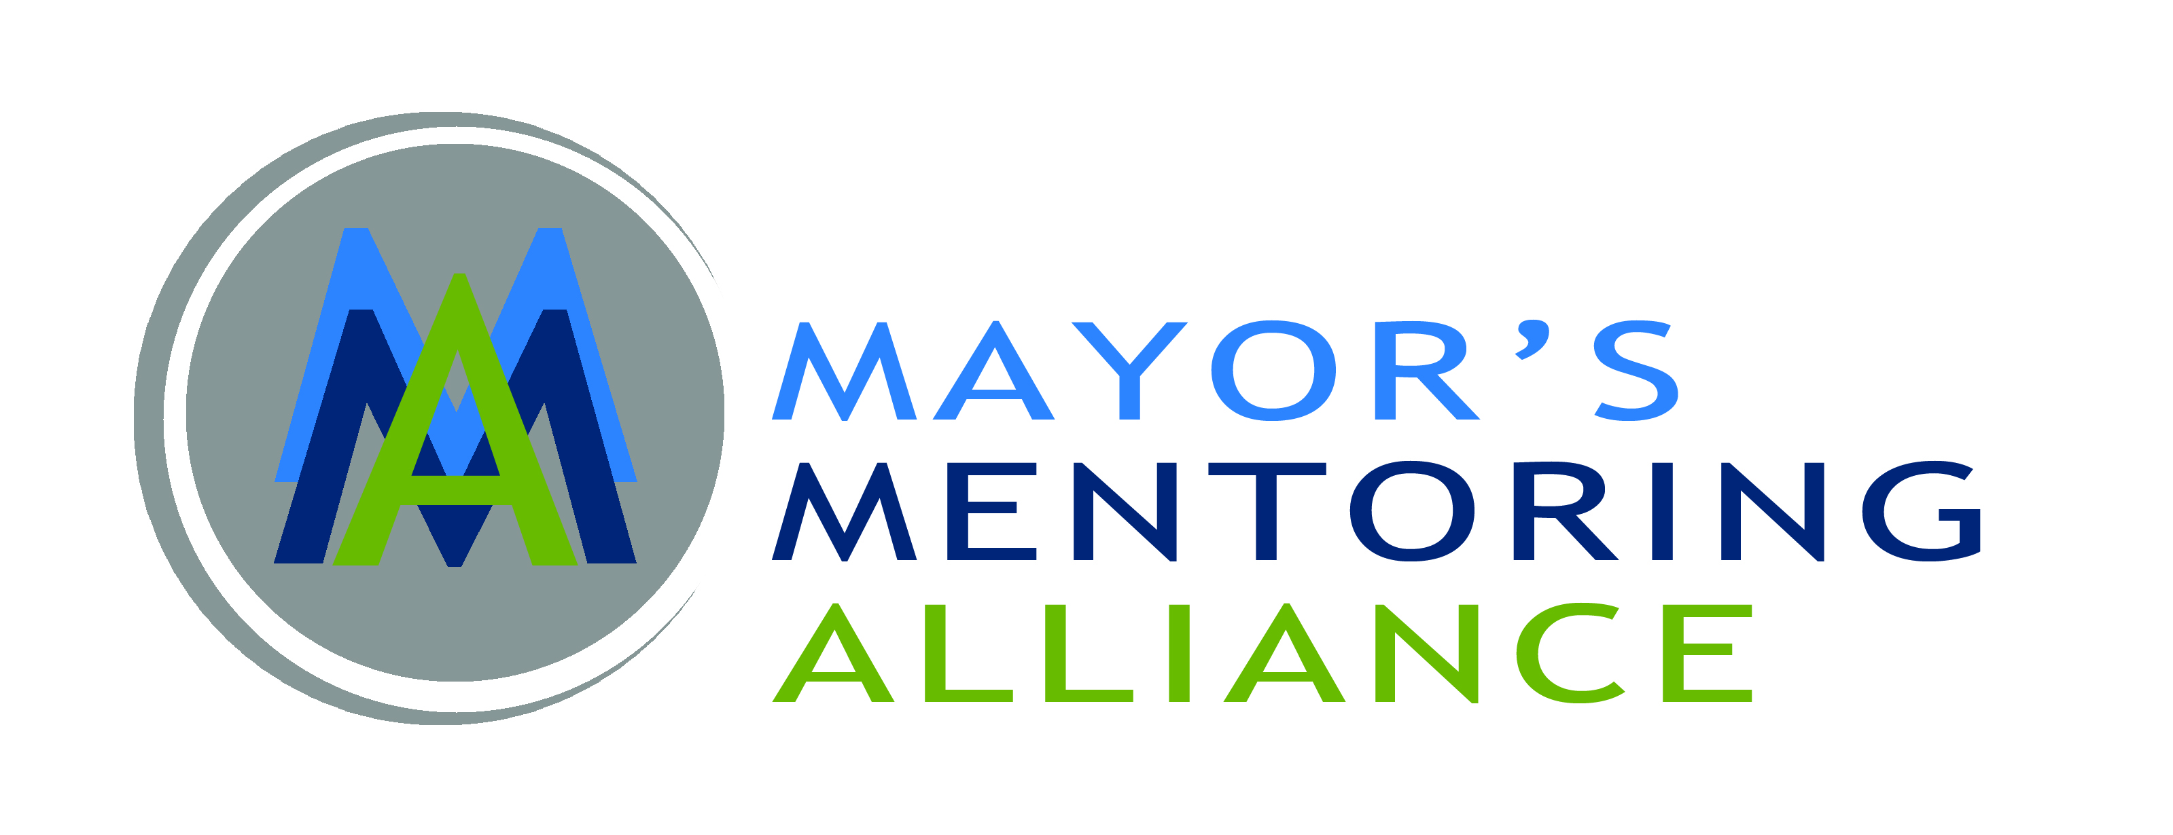
City of Charlotte
Application for Boards and Committees

Personal Information

First Name: Last Name: E-mail:

Street Address: City: State: Zip Code: Date of Birth: Home Number: Work Number: Cell Number:

City Council District (Circle your district)

1 2 3 4 5 6 7

Other

Registered Voter: ☐Yes
☐No

Political Affiliation:

☐Democrat ☐Republican ☐ Independent

☐Other

Diversity Information

Age:

☐Under 30 ☐30-39 ☐40-49 ☐50-59 ☐60 & Over

Gender:

☐Male ☐Female

Race/ Ethnic Background:
☐African American  ☐Native American  ☐Other | ☐Asian | ☐Caucasian | ☐Hispanic/ Latino

Spouse Information

Spouse's Name: Spouse's Employer: Spouses Job Title:

Boards / Committees

Select up to 2 Board Chair positions, or committees which you are interested in participating in.

Choice One: Choice Two:

Please provide a brief statement for the following questions:

Why are you interested in serving on these boards/ committees? (Max 400 characters)

How have you been involved in mentoring, volunteering and/or the community?

Please describe any background or abilities that qualify you to serve on these boards/ committees.

List any boards you are currently serving on:

List any boards you have served on in the past:

Employment History

Current Employer:

Years in Current Position:

Job Title:

Brief Description of Duties: (Max 400 characters)

Other Employment History: (Max 250 characters)

Education History

Education:

☐High School ☐College ☐Graduate School

☐Other

Additional Education History: (Max 400 character)

Affirmation of Eligibility

Has any formal charge of professional misconduct ever been sustained against you in any jurisdiction?

☐Yes ☐No

If yes, please explain complete disposition. (Max 250 characters)

Do you have any personal or business interest that could create a conflict (either real or perceived) if appointed?

☐Yes ☐No

If yes, please explain conflict. (Max 250 characters)

How did you find out about the Mayor’s Mentoring Alliance Board and Committee vacancies?

☐City of Charlotte Website ☐Social Media

☐Email ☐Newspaper

☐Word of Mouth ☐Recruited by current Committee Member

☐Other

Boards/ Commissions Disclaimer

I certify that the information provided in this application is true and correct to the best of my knowledge. I authorize and consent to background checks and to the investigation and verification of all information contained herein. I further authorize all persons having information concerning my qualifications to release information to city representatives and release such persons from all liability for any damages connected with the release of such information. I also release and discharge the City of Charlotte from any claims and damages, losses, liabilities, costs, expenses or any other charges or complaints arising out of the City's use of any information provided pursuant to this release. I understand and agree that any misstatement will be cause for my removal from any board or committee. By submitting this application, I agree to adhere to all city policies pertaining to boards and commissions, including attendance. I understand that affixing my name in this form is deemed an electronic signature that has the effect of a written signature and will be presumed a valid signature, absent notification otherwise.

I hereby acknowledge that this application and information provided herein may constitute a public record, and as such, may be released in accordance with all applicable public record laws. ☐Please check this box after reading the above disclosure statement.

Signature: Date Signed:

All applications are purged after one year

FOR OFFICE USE ONLY: Application Received: Board of Election Verification:

If you have any questions about the application process, please contact Angie Gover, Mayor’s Mentoring Alliance Supervisor, at 704-336-2928.

