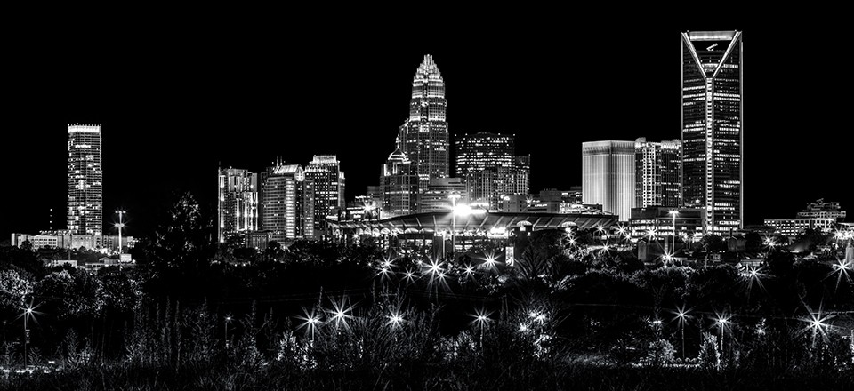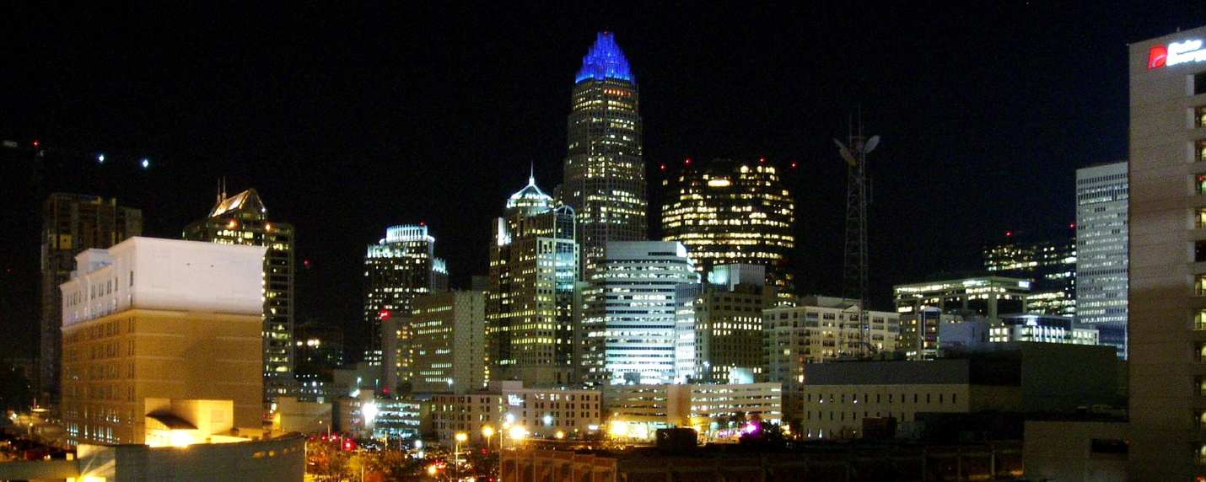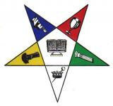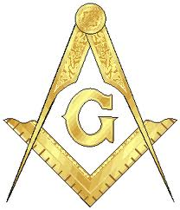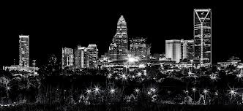

**Prince hall WEEKEND festival & worship service**

**September 13th – 15th 2013**

**Prince hall - FIRST and forever**

**Prince Hall Weekend Service**

**Sunday Sept. 15**

**3:00pm – 4:30pm**

**Nazareth Primitive Baptist Church**

**2230 Bancroft St.**

**Charlotte, NC 28206**

Community scholarship walk 8am-Double Oaks

Free Health Fair Backpack Giveaway

Free School Supplies Kids Activities

Food Giveaway Vendors & More

SPONSORED BY:

The Charlotte, North Carolina Prince Hall Masons and the Order of Eastern Star 32nd and 33rd Districts

**Prince Hall Inspirational Service**

**Friday Sept. 13**

**7pm -8:30pm**

**Double Oaks Masonic Lodge**

**1326 Prince Hall Ave.**

**Charlotte, NC 28206**

**Prince Hall Day Festival**

**Saturday Sept. 14**

**1:00 PM—5:00 PM**

**Double Oaks Masonic Lodge**

**1326 Prince Hall Ave.**

**Charlotte, NC 28206**