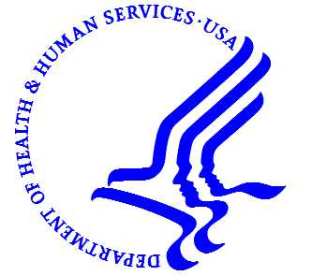
U.S. DEPARTMENT OF HEALTH & HUMAN SERVICES
OFFICE OF THE SECRETARY
REGION IV
Alabama ●Florida ●Georgia ●Kentucky ●Mississippi● North Carolina ●South Carolina ●Tennessee
61 Forsyth Street, Suite 5B95, Atlanta, GA 30303
404-562-7889 (Phone) 404-562-7899 (Fax)

FOR IMMEDIATE RELEASE Contact: HHS Regional Office
Monday, April 30, 2012 (404) 562-7910 or
(404) 574-0522

MEDIA ADVISORY

HHS Official to make Major Affordable Care Act Announcement in Charlotte

Alexia Kelley to tour and visit C.W. Williams Community Health Center

Alexia Kelley, Director of the Center for Faith-Based and Neighborhood Partnerships at HHS, will visit the C.W. William Community Health Center in Charlotte to make a major announcement about how the health reform law, the Affordable Care Act, expands the footprint of community health centers. For more than 40 years, community health centers have delivered comprehensive, high-quality preventive and primary care to patients where they live, and the Affordable Care Act makes a major investment in expanding their ability to serve patients. Kelley will tour the C. W. Williams CHC to see how patient care is delivered, and will make the announcement following the tour.

WHO: Alexia Kelley, Director of the Center for Faith-Based and Neighborhood Partnerships (The Partnership Center) at the U.S. Department of Health & Human Services (HHS)

WHEN: 11 a.m., Thursday, May 3, 2012

WHERE: C.W. Williams Community Health Center, Inc.,
333 Wilkinson Blvd., Charlotte, NC, 28208-5631

CONTACT: Deric Gilliard, deric.gilliard@hhs.gov, (404) 562-7910 (office) or
(404) 574-0522 (cell)

Event is open to credentialed members of the media only
# # #

