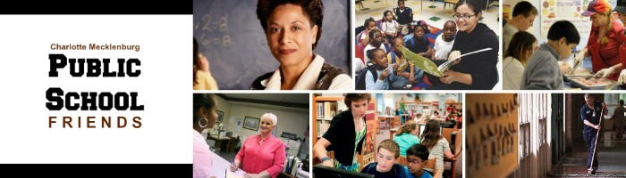

Dear _______________

As a friend of public education, I know you share my concern about the current situation in our county and state. We are 48th in the country in per pupil spending and 46th in teacher pay.
- We need to act now and we need your voice.

Join me, and other Public School Friends, in persuading our county commissioners and state legislators to fully fund the Charlotte- Mecklenburg school budget for fiscal year 2014-15. That budget, created with unprecedented input from the public, includes a pay raise for CMS teachers, more money for personalized learning, well-funded social and emotional support staff and services, and teacher training for early literacy.

By May 20, please take one minute, three minutes or five minutes to let our elected leaders know you care about quality public education in Mecklenburg County and have great respect for the teaching profession.

One minute:
- Sign the Public School Friends Petition
- Forward this email to at least 5 friends

Three minutes:
- Send your county and state representatives your version of the email below. To find out the elected officials in your specific district go to the Mecklenburg Board of Elections site.
- Forward this email to at least 5 friends

Five minutes:
- Write your own email to your county and state representatives. This is the most effective form of persuasion. It can include the following elements:
  - Why public education matters to you – tell a one-sentence personal story
  - Your district number or your address
  - A request to fully fund the CMS budget for 2014-2015
  - The assurance that you will stand with them and support their decision to fully fund the budget
  - The assurance that you will encourage your other elected officials to do their part
- Forward this email to at least 5 friends

And stay connected. The state legislature will convene next week and Governor McCrory proposed a new framework May 7 to raise teacher pay. As a Public School Friend, we will keep you informed of upcoming events and opportunities to make your voice heard. Please “Like” our Facebook page and sign up for regular email update.

I hope you will join me in this effort and at the Government Center on June 11th at 4 p.m. to rally around Charlotte-Mecklenburg Schools employees. I will keep you informed of details as we get closer to that date. Thank you for joining me, and so many other Public School Friends, to make a difference in Charlotte-Mecklenburg!

(Your Name)
P.S. Please let me know if you do not want to receive any more information from Public School Friends.

Sample email
Dear _________

As a constituent and a supporter, I am asking you to vote for fully funding the Charlotte-Mecklenburg Schools budget for fiscal year 2014-2015. This budget was created with unprecedented input from the community and I want to join the chorus of support for this important investment in Charlotte’s future.

As a Public School Friend, I care deeply about the availability and accessibility of quality public education in Mecklenburg County and have great respect for the teaching profession. I believe that a pay increase for CMS teachers, increased funding for personalized learning and instructional support, well-funded social and emotional support staff and services, and teacher training for literacy teachers in the early grades are all vital to ensuring that this community continues to provide quality education for every child. It is also a critical time to send a message to our teachers about how much we respect and value their service.

I will support your decision to fully fund the CMS budget for fiscal year 2014-2015 and will also contact my other representatives to encourage them to do their part. Thank you for your time and leadership.

Sincerely,
(Your Name)

Street Address
City, State Zip Code

