Wednesday, November 27, 2013 1:49 PM
Reggie and Mr. Roper.

What a great victory for the citizens of Charlotte with the passing of the new Citizens Review Board ordinance.

The Males Place made a great impact on the vote and the community's opinion. By allowing your young men to articulate our argument from the perspective of young black men was powerful.

http://www.wsoctv.com/news/news/local/city-council-gives-more-power-police-disciplinary-/nb4sy/

I also appreciate your young men attending the city council meeting last month in support of the CPMD being required to turn over Internal Investigation files to CRB.

After attending your meeting last week, I was emotionally moved by the young men's input on the white supremacy presentation. The way that you presented the history, civil rights implications and even incorporated hip hop culture into the discussion was amazing!

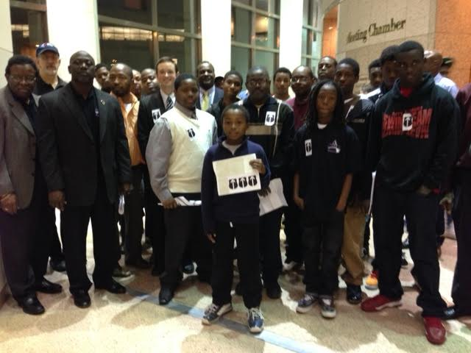

The further discussion on manhood, privatized prisons and the prison pipeline was similar to my grad school class and the 10-15 year olds grasped all of the main points.

Really commendable work.

I am forwarding this email to all of my friends and network and hopefully some will be contribute to The Males Place end of the year event at the Harvey Gantt Center on December 20th. I know that the Gantt Center is providing the space for free but the $500 for security and clean up can by a burden on a small 501 C3 like yours.

I am asking all of my friends to chip in before the December 20th event. If my friends could come up with $1000, that should also allow you to buy the fancier plastic wear and supplies for the party.

I really think that your young men deserve the support. I will start off by contributing $50 to the effort. Any of my friends that want to contribute can make checks out to The Males Place. They can get their donations to me or Mr. Roper before December 17th.

My friends should also remember that as a 501c 3, their contributions to The Males Place are tax deductible.

Here is some more information about The Males Place for my friends.

http://charmeck.org/mecklenburg/county/HealthDepartment/CommunityHealthservices/malesplace/Pages/Default.aspx

http://charmeck.org/MECKLENBURG/COUNTY/HEALTHDEPARTMENT/COMMUNITYHEALTHSERVICES/MALESPLACE/Pages/MalesPlaceInfo.aspx

https://www.facebook.com/pages/The-Males-Place/182402522616

http://www.qcitymetro.com/qcitymetroblog/post.cfm/the-males-place

http://www.wcnc.com/news/health/The-Males-Place-teaches-boys-to-become-men-104086939.html

Thanks for all your hard work turning boys to men.

Robert Dawkins
Western NC Field Organizer
Democracy North Carolina
(704) 957-3105
robertdawkins@democracy-nc.org
www.democracy-nc.org

