Attachment # 1
TRUTHS MY TEACHER NEVER TOLD ME:
An Analysis of History Textbooks and Public
Mis-Education with Wholistic Solutions
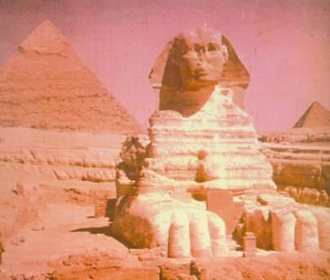 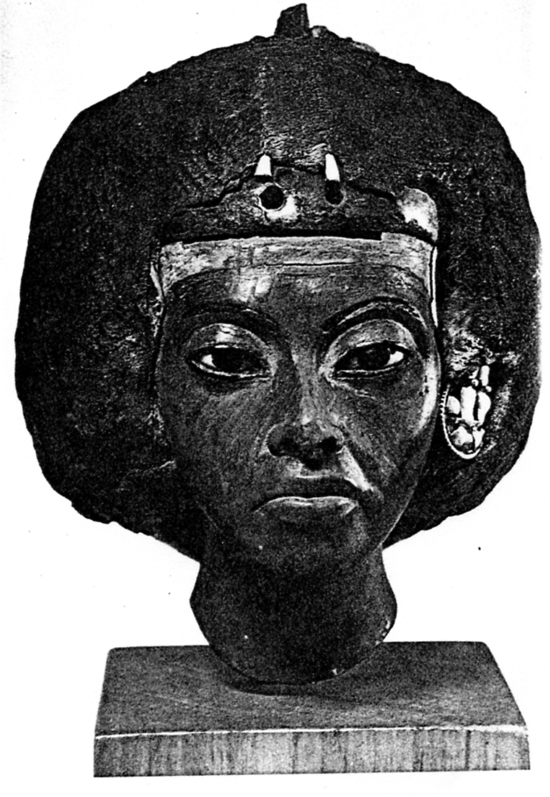 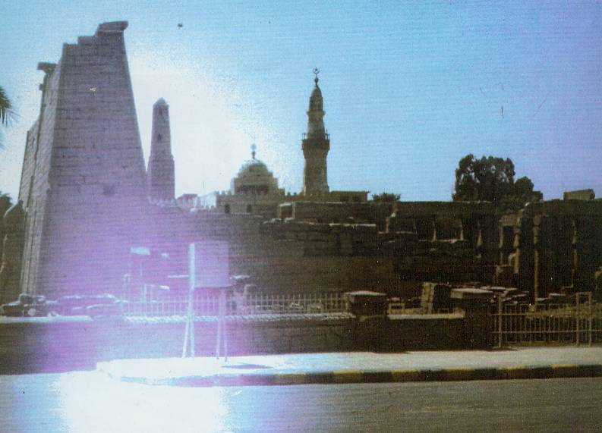 Hor-Em-Aket (Sphinx) and “Horizons QUEEN TIYE Ruins of Ipet-Isut —“The Holiest of Places"
Of Kemetic (Egyptian) Kings, -- the first university in the world in ancient
under-girded by a profound philosophy- Kemet (Egypt).
theology of liberation-salvation..

“Those who do not treat you right cannot be expected to teach you right.”
--Elijah Muhammad—

“I’m tired of hearing of a Black history which begins with slavery. A perfect example is the popular Black history book, From Slavery to Freedom. Wherever there is humanity, you find Black people. I want all Black people to embrace their African-ness. Why is this important for us? Because we are trying to become whole again. What you do for yourself, depends on what you think of yourself. And what you think of yourself depends on what you’ve been told.”
--Dr. Runoko Rashidi --

“The fact that we Africans in America lack a thorough knowledge of self and others is taking a devastating toll upon us. If our children knew our ancestors created the first civilizations and the great cultures of the Nile Valley, Nubia, the Sudan, Ethiopia, Southern Africa, Mesopotamia and Indus Kush, would they still kill each other over sneakers and clothing with other folks’ names, images and logos on them. I don’t think so!.”
--Junious R. Stanton “The Power of History”--

“My people are destroyed for lack of knowledge”
-- Hosea 4:6, The Holy Bible—

Minister (Dr.) Gyasi A. Foluke

OVERVIEW

"America Can't Deal With Reality -- We Must Be Exposed to the Truth, Even If It Hurts. Many people inhabit a closed belief system on whose door they have hung the 'Do Not Disturb' sign."
-- Bill Moyers--

In this book, the author examines the inherently controversial issue of racial bias--omissions or distortions--in two academic textbooks on World and American history respectively, in the context of problems in public mis-education, with related-proposed wholistic solutions. It is a follow-up to his first book, The Real-Holocaust: A Whoistic Analysis of the African American Experience, 1441-1994 (1995-07)--more specifically to Chapter 7, "Mind Destruction," and to his third book, The Crisis and Challenge of Black Mis-education in America: Confronting the Destruction of African People Through Euro-centric Public Schools (2001). Initially, he embraces, in part, “The Ghost of Dr. Carter G. Woodson”—the Father of Black History Week-Month—who in his classic book, The Mis-education of the Negro (1933), proclaimed that African Americans should not expect to be educated, authentically, in an “antiquated” public school system, designed to promote the socioeconomic interests of White Americans. Furthermore, Woodson proclaimed, many professionally “educated” or mis-educated Blacks were all but “worthless” in promoting the collective development of their people.
After identifying both micro and macro problems related to textbooks and mis-education--"The Funeral Syndrome Under Majority Tyranny"--the author provides an abridged outline or examples of thirty six specific topics that constitute "The Big Cover-up" of truths related generally to Euro-centric textbooks. Subsequently, he offers a general assessment of these books, followed by meticulous analysis of two specific textbooks, providing support for his earlier (1995 and 2001) premises on the underestimated damage-destruction uniquely to Blacks through mis-education and socioeconomic oppression-suppression in the larger society. Moreover, he offers conclusions and over 40 specific recommendations to promote wholistic reforms-changes in the public school system and broader society--seeking to male of us "whole."
In essence, the author, proclaims the partial-major failure of both the racially segregated and desegregated-"re-segregated" school systems, while advocating a synthesis--combining the best of both of these two failed systems--into a new Pyramid Model of wholistic--spirit, mind, body--development. And these proposals also mandate changes in two prevailing thought patterns of reform, the “victim deficit” and “system deficit” models of change respectively, i.e., a balanced focus on "disadvantaged" students, with a much stronger focus on a deficient educational-socioeconomic system.
Finally, as an aspect of both old and new systems, the author proposes, as appropriate, the creation of a series of African-centered Supplemental Centers within public schools, the potential "re-structuring" of school boards, as well as temporary--from three to five decades--of African-centered, charter-school education for many Blacks, as a critically-needed corrective for protracted public school mis-education. He also proposes a “new” philosophy of education-human-Divine salvation, based mainly on precepts in ancient Africa, B.C.E. And this philosophy extends, inexorably, to the socioeconomic system where "Ma'at"--truth, justice, and righteousness--or "the balancing of the land," becomes the ideal operative-normative value throughout society.

CONTENTS

"White society has taken the best from the African and African American people and claimed it as their own, while portraying or misusing the worst aspects of our condition/behavior--"bitter fruits," sown mainly by Whites---as a weapon to destroy us."
--Gwendolyn H. Haynes, Oklahoma City, Oklahoma, 1990—
"I'm for truth no matter who tells it. I'm for justice, no matter who is for or against it. I'm for a human being, first and foremost, and as such I'm for whoever and whatever benefits humanity as a whole."
---Malcolm X---
DEDICATION MASTER TEACHERS--Dr. John Henrik Clarke and Dr. Yosef ben Jochannan………………….........…………10
IN MEMORIAM DR. ASA G. HILLIARD III..……………………………...............…...11
PREFACE PERSONAL NOTES: The Ghost of
Dr. Carter G. Woodson....................….......………....13
INTRODUCTION IN SEARCH OF “HIDDEN” TRUTHS-MA’AT …….......…..………20
CHAPTER I THE BIG COVER-UP: Specific Examples of “Isfet”-Lies or “Hidden” Truths Outlined……......……...…….32
(1) Theft of our Ancient Black Heritage--a Stolen Legacy........................................33
(2) The Failure to Analyze-Address Systemic Genocide or So-called "Black-on-Black" Homicides ............................................................................36
(3) The Failure to Identify and to Analyze Multi-Dimensional Racism
and its Major by-product, Internalized Victimization......................................38
(4) An Absence or Paucity of Analysis on Sub-Sahara-Modern Africa..................41
(5) Abraham Lincoln: No "Great Emancipator" of Blacks.......................................42
(6) The Stolen Statue of Liberty...................................................................................43
(7) Kill Them Before They Grow--"Hidden" Conspiracy to Destroy
Black Males........................................................................................................43
(8) "Low-hanging Fruit," the "Hidden" War on Blacks or
So-called "War on Drugs".................................................................................45 (9) Obscuring Affirmative Action and Failure to Enforce
Civil Rights Laws...............................................................................................46
(10) Dr. Martin L. King Jr., Promoting the "Dream"--
Hiding the "Scheme"..........................................................................................47
(11) Christianity Changed-Projected Falsely as "the White Man's
Religion," with a Created-Concocted White IMAGE of "Jesus"....................48
(12) The Secret is no Secret--Only One, Paradoxically, of Seven Divine
or Natural Laws Taught in Ancient Africa..........................................................51
(13) The Old Lie of Columbus "Discovering" America Still Alive .............................53
(14) "Hidden" Anti-Racist Work of Great Whites in America.....................................54
(15) Promoting-Extolling Scoundrels in America, The Scoundrel
Syndrome..............................................................................................................55
(16) Black Lynching: An Underestimated, Distorted, Photographically "Hidden" Barbaric Practice....................................................................................57
(17) "Hidden" or Underestimated Urban Pogroms or Anti-Black
"Race Riots".......................................................................................................59
(18) The "Hidden" Art of Creating Leading Blacks and
Destroying-Neutralizing Black Leaders.......................................................60
(19) Embracing-Accepting the Names of Slave Owners..............................................61
(20) Distorting the Role of the Traditional White Church.............................................62
(21) Black Slavery as Economic Foundation of America.............................................64
(22) Systemic Medical Experiments on Blacks.............................................................64
(23) Protracted Mistreatment of Black Military Troops................................................65
(24) "Black Fought for the Confederacy"--The Big Lie..................................................66
(25) "Hidden" Black contributions to America, Including
African Symbols..................................................................................................67
(26) "Hiding"-Underestimating Police-Prison Brutality.................................................69
(27) Excluding-"Hiding," Banning or Circumventing Books
Most Relevant to Blacks....................................................................................70
(28) "Muslim" Terrorism Condemned, While "Christian" Terrorism
Ignored or Minimized.........................................................................................71
(29) Non-Biblical White Jews, Friends or Foes of Blacks--
a "Hidden" Record.............................................................................................72
(30) Failure to Address Multi-Dimensional Patriotism................................................ 75
(31) Black Role in "Winning the West" Under-estimated................................ ............76
(32) "Hidden" Historic Proof: Racism as Learned Behavior............................. ...........77
(33) "Hiding" Truth Behind the "Two Americas"..........................................................78
(34) The Rape of Haiti and its "Hidden" Gift to America..............................................79
(35) "Ask Not What Your Country Can Do For You, But Ask
What You Can Do For Your Country"--"Hidden" Source
of a Great Political-Spiritual Phrase.................................................................81 (36) Southern Reconstruction--"NOT"--Even Under the "New South"....................82
CHAPTER 2 PROBLEM IDENTIFICATION: The Funeral Syndrome Under Majority Tyranny……………........……..…..…...……..... 86
CHAPTER 3 GENERAL ASSESSMENT: The Importance
of Authentic Education…………........………,..,……….....…….128
CHAPTER 4 SPECIFIC ASSESSMENT: World History: Patterns
of Interaction, 1999................................. ………..……….….…147
CHAPTER 5 SPECIFIC ASSESSMENT,
The Americans, 2001: “His story” and “Our story”…..........…193 CHAPTER 6 CONCLUSIONS-RECOMMENDATIONS:
Confronting "A Burning Fire " Through “Ma’at” With Specificity ……....……........….....…….….259
APPENDIX
A. Outline: “Family Values”: Genocidal Public Policies that
Destroyed-Damaged Black Families............................................................292
B. Article, Unsung Heroes, with attached selected photographs.............................295
C. Article, Obama, Clinton and "Bouzaunga"..............................................................300
D. Article, When violent chickens come home to roost..............................................301
E. Preface: Einstein on Race and Racism.....................................................................303
F. Article, Foreign Aid and The Three Rapes of Africa...............................................304
G. Article, “Belonging”: Confronting the Color of Patriotism......................................306
H. Article, The Race Relations Game.............................................................................307
I. Article, When Politicians Sell out Our Interests........................................................309
J. Article, When are WE Going to Get Over It?.............................................................314
K. The Spirit of Barack Obama’s Impact on America....................................................315
L. Statement to the Charlotte-Mecklenburg Board of Education, 4/8/03.....................317
M. Article in Educate!: Major damage has occurred, 4/17/03.......................................321
N. Article in Educate!: Schools need new approach to meet
Blacks’ special needs.............................................................................................323
O. Article, CMS Re-structuring: “That Dog Won’t Hunt” 2/17/06..................................325
P. Article, Obama and Blacks: Beyond The Euphoria...................................................327
Q. Report Card: Mecklenburg County Commission......................................................329
R. Article, Racial Discord: The Failure of Leadership..................................................330
S. Article, New Warning for ADHD Medicines.................................................................332
T. Dr. Martin L. King Jr. Speaks .......................................................................................333
U. Article, The Academic Gap Game................................................................................334
V. Article, CMS Review to Nowhere.................................................................................336
POSTSCRIPT: STOP SYSTEMIC GENOCIDE NOW............................................................... 338 ABOUT THE AUTHOR-LECTURER* 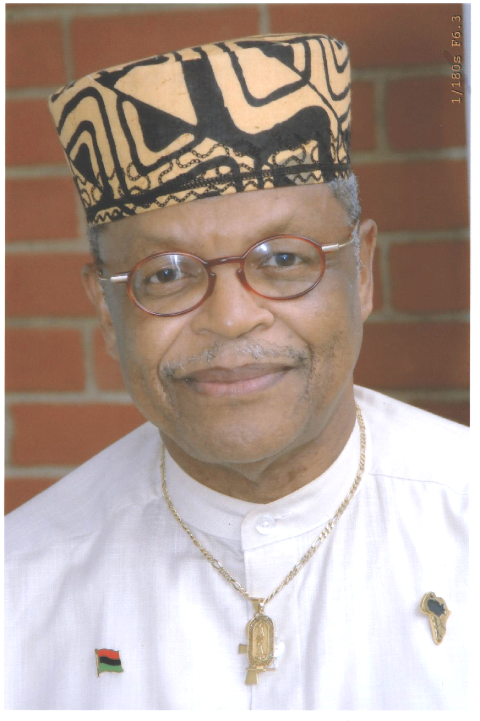 
Minister (Dr.) Gyasi A. Foluke
An author-lecturer-consultant, Nontraditional Minister (Cosmic Christian-Universal Spirituality), and part-time CEO of The Kushite Institute for Wholistic Development in Charlotte, NC, Minister Dr. Gyasi A. Foluke has been an activist-scholar-author in the struggle for human rights and dignity for over 50 years, beginning at age l6 when he established the first Youth Council of the NAACP in his hometown of Columbia, SC.. As a senior high school student, he also wrote the Alma Mater for the new C.A. Johnson High School. Having written many professional articles, monographs and studies to promote wholistic—spirit, mind, body—development, including social-institutional change in America, he is the author of The Real-Holocaust: A Wholistic Analysis of the African American Experience, 144l-1994 (1995-07)--used as a textbook at the University of Oklahoma per attached "Testimonials"--The "Old Time Religion": A Wholistic Challenge to the Black Church (1997)--stolen by a bankrupt publisher--The Crisis and Challenge of Black Mis-education in America: Confronting the Destruction of African People Through Euro-centric Public Schools, (2001), The Scoundrel Syndrome: Essays on the African American Experience, 1996-2003, (2004), and Truths My Teacher Never Told Me: An Analysis of History Textbooks and Public Mis-Education, with Wholistic Solutions. (2011)
A graduate of Howard University, Washington, D. C., 1958 (BA Political Science/Economics, Magna Cum Laude) and American University, Washington, D.C., 1960 (MA Public Administration), the author has pursued 6 years of additional post-graduate studies at several universities-institutions and protracted (over 35 years), of independent, academic-supervised research on Black Studies, Religion-Metaphysics, while earning a Non-traditional Doctor of Divinity Degree from the Neotarian College of Philosophy, Kansas City, Missouri, 1981. (Thesis: Universal Oneness: Metaphysical Perspectives on Life). He also served as Adjunct Professor-Lecturer of Black Studies at six universities and colleges, beginning at Creighton University in 1969, and completed two study tours to Africa (Kemet/Egypt, 1986 & 1991) and a trip to Ghana (2002) where he lectured at Wenneba University, Wenneba, Ghana.
A former Air Force Officer/Intelligence Analyst (11 years) who officially was evaluated as “a consummate expert on race relations matters” at the Armed Forces Staff College (1972), he served subsequently as Social Action Officer and Chief of Training, USAF School of Social Actions (5 years) with responsibilities for teaching instructors in Race Relations Education, Drug/Alcohol Abuse Prevention/Treatment and Equal Opportunity/Treatment. Later, he served as President/CEO of several nonprofit corporations, including the Tarrant County/Forth Worth anti-poverty agency and two Affiliates of the National Urban League, creating or managing over 50 socioeconomic programs for poor and “disadvantaged” citizens. He was a non-traditional Air Force Officer, having spent most of his off-duty time working in the civil rights movement, including brief work with Dr. Martin L. King Jr. in l963. He also opposed the war in Vietnam in l966 and paid a price for his moral-professional posture--later proven correct by Cabinet level officials through their belated-profitable books. A recipient of numerous awards for community service and winner of the Bronze Star Medal, he is listed in Who’s Who in Black America, 1985.
*The author provides power-point presentations, seminars and wholistic messages on his work.
Testimonials

As printed on the back cover of The Real-Holocaust, 2007 Edition (Foluke, 1995)

“During my class on “Critical Issues in African American Studies” at the University of Oklahoma, The Real-Holocaust served as a highly effective academic tool because it afforded students the opportunity to become acquainted with historical, economic, and spiritual issues from the point of view of the oppressed.”
--Khepra NuRa Khem, PhD—

“A book for Economic Empowerment, The Real-Holocaust by Gyasi A Foluke brilliantly illustrates the African American experience in the Western Hemisphere. To get an in-depth look at where we have come from will help to get to where we should be. “
--Harry C. Alford, President/CEO, National Black Chamber of Commerce, Inc.—

“Dr. Foluke’s subject matter selection, analysis of documents, and insight into phenomena reflect a great degree of scholarship. His work contributes to the social, political, and economic knowledge base of the country, its communities, and people.”
--Dr. Warren C. Hope, Associate Professor, Florida A&M University—

“The Real-Holocaust is a factual account of the African American experience by a consummate expert in the area of race relations and intercultural relations. On a personal level, I know him to be a man of his word, with impeccable character and integrity.
--Attorney John R. Ross, President, Dallas County/White Rock NAACP—

“This book was very enlightening and provided me with a tremendous thirst for knowledge about my history and my ancestral background. Many of the chapters told stories of the abuse of our women, men and children, the countless number of rapes, beatings and senseless killings. The chapters dealt with the big picture, and laid a foundation about the lasting effects of The Real-Holocaust experience, while analyzing the psychological, emotional, spiritual, and economical oppression we feel today.”
--Mia Fleming, Student, University of Oklahoma--
*********************************************************************
Ankh
Ancient Kushite-Kemetic symbol of LIFE, translated as the Divine or Natural Law of Opposites--male-female, light-darkness, positive--negative, liberal-conservative, etc--with both opposites containing aspects of the other opposite, e.g., some male in every female, liberal in every conservative and vice versus. Theologically, it represents the fourth or creative power of God beyond the Trinity--the monotheistic ONE that permeates all life on this mundane or earth plane of existence. And the goal of generic man is to become and later to BE Godlike--aware or spiritually attuned to his real God-Self--as we follow self-transcendent patterns of Divine Heroes, historical and/or mythological, such as Heru (Egypt), Zoroaster (Persia), Jesus (Israel), Krishna (India), etc, in quest of enriched lives through BALANCE and HARMONY by extracting-obtaining the best aspects, talents, partnerships and/or features between both opposites. Amen!

