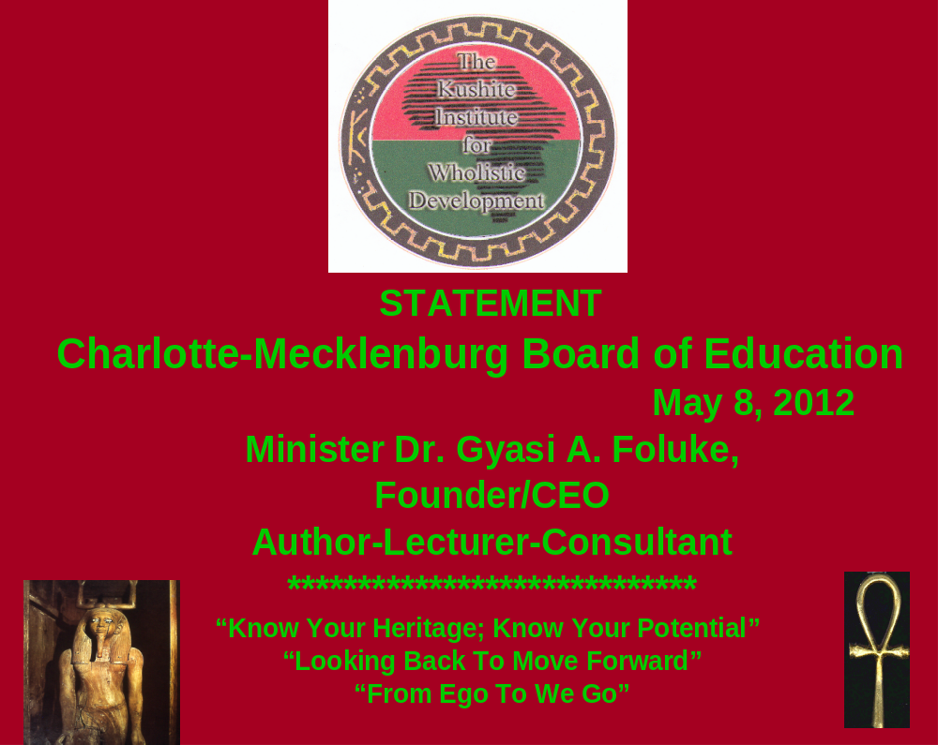 North Carolina Superior Court Judge Howard Manning "speaks" on "academic genocide" in low performing public schools--the Leandro case. However, while generally this Author concurs with Judge Manning, the enclosed "STATEMENT" FAR transcends the issue of low performing high schools, with CRISIS concerns over the EDUCATION of all students, beyond relatively superficial test scores. For there are many serious, unresolved "racial" issues over cumulatively disadvantaged African American students and parents that MUST be addressed by CMS and adjacent community.
***************************************************
"It's not about you, it's about these children. You are killing off their opportunity for a decent job and decent life. You're violating their constitutional rights every day you run the ship the way you do...
"Teachers who expect little of poor and minority students should be 'tarred and feathered.' And principals who won't get rid of such teachers are 'a cork in the bottle'...I'm deadly serious. This cannot go on. When I talk about change and the Governor talks about change, we're not going to nibble on the edges of these high schools. Principals who aren't willing to replace those teachers need to hand in your resignation this afternoon."
Minister Dr. Gyasi A. Foluke, Author-Lecturer-Consultant
Charlotte, North Carolina
Phone 704 391 5582
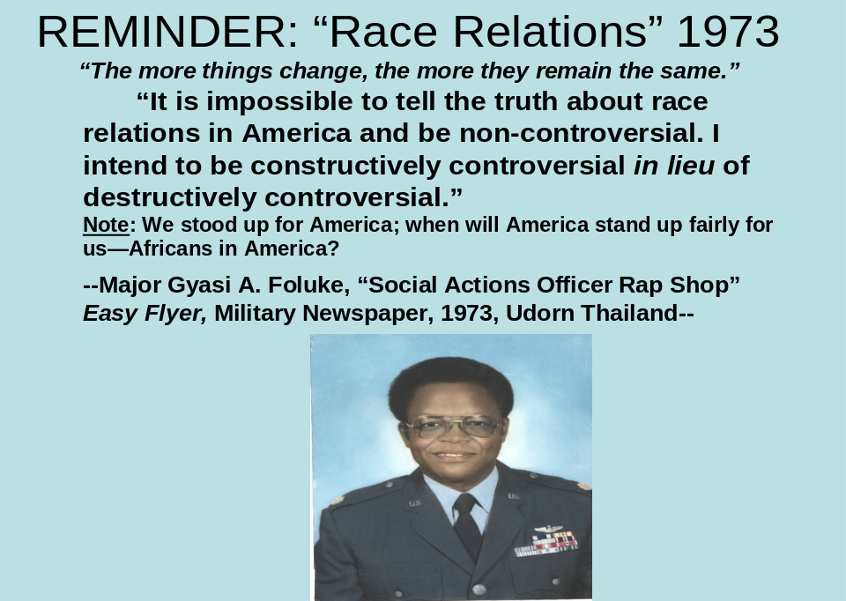
STATEMENT* May 8, 2012
To: Charlotte-Mecklenburg Board of Education:

Madame Chairperson and members of this distinguished CMS Board of Education, my name is Gyasi A. Foluke (Jar-see Fo-Low-Key), an Author-Lecturer-Consultant, Non-traditional Minister (Cosmic Christian-Universal Spirituality) and part-time CEO of The Kushite Institute for Wholisitc Development in Charlotte, N.C. I am here this evening to encourage you, once again, to obtain copies of my most recent book, Truth My Teacher Never Told Me: An Analysis of History Textbooks and Public Mis-education with Wholistic Solutions, i.e., those proposed "solutions" which should help to make all of us "whole," through "Seven Dimensions of Freedom," as outlined on the last page of this Statement. Moreover, I also encourage you to sponsor and to schedule a Seminar--a minimum of five hours in duration--or a Workshop of seven-hours to be facilitated by this Author for this Board, top administrative officials and your professional teacher development staff. Indeed, this proposed, critically needed Seminar or Workshop, should help to delineate and to promote better understanding of the ongoing CRISIS of many disadvantaged African American students, as well as all other students, across ethnic lines, in receiving a critically-needed, balanced, wholistic education. And this latter education is defined as spirit-mind-body development, based upon the ancient African principle of "Ma'at," i.e., truth,, justice and righteousness, one which would sustain or not violate the wise principle of separation of church and state.
__________________________
*Copyright (c) , Gyasi A. Foluke, 2012. This document may not be used and/or duplicated, in whole or in part, without the expressed written permission of the Author.
While I encourage you to read this entire formal statement, with attachments, let me "cut through the chase" and inform or remind you that this crisis cannot be resolved successfully, under a "win-win" posture, without confronting, honestly, those MAJOR, UNDER-ESTIMATED DAMAGES, both psycho-social and economic, that have been inflicted perennially-cumulatively--over 400 years--upon significant socioeconomic segments of our disadvantaged Black population. And this means that this Board, with your new Superintendent, should change some present policies, while adopting new or different strategies-policies to, in part, correct major damages cited above, using African-centered professionals--not ideological "kneegroes"*--PLEASE. Therefore, in Chapter six (6) of my new book, Truths My Teacher Never Told Me (2011), I have proposed about thirty (30) major recommendations and many more relatively minor ones, with appropriate commentary, by this Author. And these recommendations are divided into three (3) broad categories as follows:

1. Seventeen (17) major and nine (9) related recommendations-comments for the present "desegregated-re-segregated" school system, which, as noted above, has experienced considerable FAILURE in EDUCATING African Americans. Moreover, if these proposed changes are embraced and sincerely implemented, we could make extensive progress in education, locally and perhaps nationally.
2. Seven (7) major and twenty seven related (27) recommendations- comments for a newly proposed synthesized Pyramid Model System--acronym PMS, no pun intended--under a "new" philosophy and system of education--combining the best of the old and present systems. And this synthesis, to reiterate, would include a degree of temporary, voluntary, corrective African-centered education, revising the old segregated order (state mandated or enforced) and the present desegregated-re-segregated system--with this temporary end product also including school "choice'". Indeed, this proposed new model, properly understood, would be a "win-win" posture for everyone, but only under the questionable assumption that the majority "power structure," again devoid of precedent, would demonstrate the fairness to share sufficient resources to facilitate success of this new PMS proposal.
3. Six (6) major and an equal number of related comments-recommendations--mainly by reference to other works by this Author--for the larger society beyond educational institutions, including unprecedented Black self-help measures--the latter, again under a questionable assumption, unprecedented, that we-Blacks could organize ourselves sufficiently for this major task.

Of course, some recommendations or changes proposed above, mainly in relation to the new PMS proposal, would require considerable time for effective or successful implementation, as we may expect some "bugs," as normal, under any significant new system. However, we should not be discouraged by this predictable factor, especially since we have few systemic options, successfully, to address this incredibly simple, but paradoxically complex educational-"racial" issue that has been created in America. More germane, I believe that the past three superintendents within CMS have not obtained their proclaimed academic or related goals, primarily because they have ignored or minimized this critically important "Polyglot Factor"--the uniqueness of "the Black experience"--by failing to devise "different remedies," some of which I have identified specifically in recommendations referenced above.
Let the record reflect also that I submitted and introduced my third book on this protracted issue to the CMS School Board in 2003, with a most descriptive-appropriate title and subtitle: The Crisis And Challenge Of Black Mis-education in America: Confronting the Destruction of African People Through Euro-centric Public Schools (2001-02). And while this nine-year old serious appeal to that 2003 School Board apparently fell on deaf ears or at least went unheeded, our ugly educational "win-lose" posture remains essentially unchanged, irrespective of grandiose promises, big salaries and financial bonuses for several superintendents--"The Houdini Syndrome" as I have narrated in a recent article in The Charlotte Post.
Clearly, there has been more than enough testimony by reputable scholars-writers, past and present, on the scope or potential national security danger of failing public schools--for whatever reasons and/or by persons, including those who either ignore or minimize this ongoing CRISIS, as defined above. For example, there is the old 1983 national report, A Nation at Risk and, locally-recently, a statement by the Editor of The Charlotte Observer on this national security issue. For this crisis not only includes those well-known test-score gaps, but at least about twenty three (23) other serious problems, challenges, issues or gaps that merit the policy attention of this school board, staff and community leaders--issues that should be included in a more comprehensive proactive policy agenda for CMS and adjacent community.
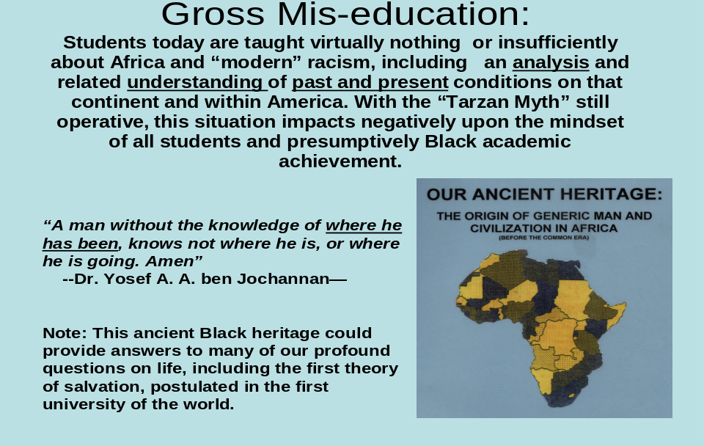
In conjunction with another, more recent statement by Superior Court Judge Howard Manning, describing "academic genocide" in certain low performing CMS schools, and yet another relevant-painful statement by North Carolina Law Professor Irving Joyner that Blacks students have "suffered" and have been "abused" since the beginning of school desegregation, the following additional examples of testimonies by scholars and writers should be sufficient to accentuate my point:

Dr. Asa G. Hilliard, III

"Most African children do not have access to a quality education. . .More of the same will not do...no race or ethnic group is superior to any other. Forty five years of Brown (1954) should be enough for people of goodwill to see that a massive new focus and effort is needed, and to resolve to take the next difficult steps. Time is of the essence."
"There is an implied universality about the curriculum of the traditional foundation courses, even as most of it applies mainly to students or school environments reflecting European American culture. It borders on professional malpractice to continue to offer teacher training that is unaffected by the academic knowledge base about African people. Teachers, however, cannot share any knowledge that they do not have or are not interested in gaining.
"We mis-teach European history, as we mis-teach American history….Basically, what we should be teaching is the whole story, the truth. That's the bottom line."

Retired Police Chief Anthony Bouza

"We continue to insist on treating Blacks as if they were another piece of America's 'polyglot mosaic,' rather than as a people who have had the unique experience of slavery, Jim Crowism, dependence, and exclusion...The unique nature of the Black experience here suggests that the psychically disabling effects of up- rootedness will require different remedies than those applied to assimilating other immigrant groups." (Note: This statement should be repeated, repeated and repeated by public officials, including school board members, until they "get it.")
"National leaders can blather all day long about lifting America's educational standards and performances, but the hard question centers on government's willingness to equalize the underclass's resources...It will take more than money to turn out an educated citizen, but the current mal-distribution of resources ensures the underclass's
failure. Bingo!
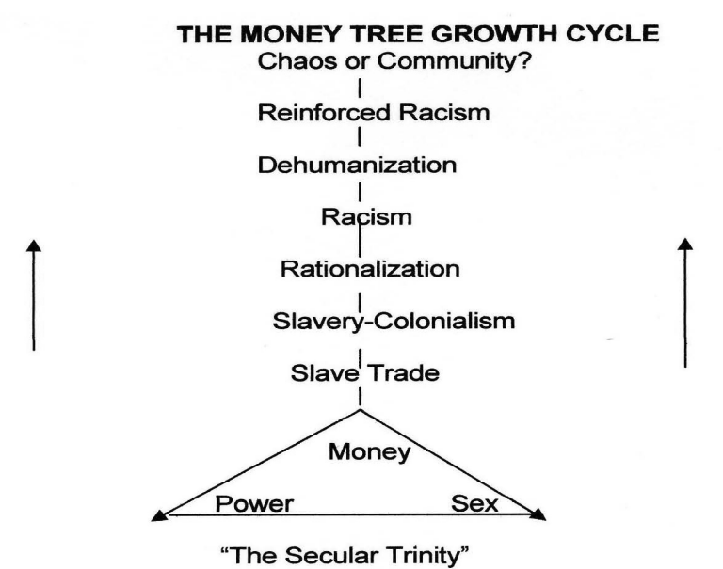
"For the love of money is the root of all evil."

Dr. Claud Anderson

“The Problem? “Nobody wants to propose Black solutions for Black problems. Society is more comfortable recommending broad minority solutions for problems that are actually unique to Black people alone. Blacks have been unable to escape from those (racist) legacies because the majority society acknowledges the operation of racism in the distant (past), but minimizes its present significance.”..
“Black Americans must not allow the vertical line of obligation between themselves and Whites to be blurred. Blacks are injured by those who do not make distinctions between them and other minority groups. Equating other minority groups with Blacks demonstrates a poor understanding of history and hides the fact that Black people remain at the bottom of the pile. Horizontal movement to align Blacks with other minority or special interest groups erases Black America’s special moral claim on our society and history. Although our labor built this country, we have not been properly recognized nor compensated. Worse, we have been treated as just another aggrieved minority group.”

Equally significant, the late Honorable Elijah Muhammad also proclaimed: "Those who do not treat you right cannot be expected to teach you right"--a truth generally that cannot be refuted under historic and current public policies or practices. And yes, there has been considerable progress in "race relations," as attested to by the ethnic composition of this school board and "the first Black President" nationally, although the President's late Mother was "White," a testimony to the unscientific absurdity of "race" in America. However, this progress should be perceived in VERY relative terms of recurring ethnic retrogression, including the long distance that Blacks as a group still must travel to obtain more than a modicum or scintilla of ethnic parity in America.

In this context and apart from "training" or the "basics"--reading, writing and arithmetic--and well-known, documented economic factors (protracted-cumulative poverty etc), those most important "different remedies" that we should address have been identified in my new book as "Internalized Victimization," including MAJOR psycho-social DAMAGES perennially inflicted on our Black disadvantaged population. And these major damages, to reiterate, with roots traceable to "the love of money," have forced Blacks, as a group-- with many individuals exceptions--into a despicable posture as a marginalized or "sedimentized" group on the bottom or dung heap of society. Accordingly, we-Blacks, today, experience repetitively, "The Roger B. Taney Syndrome"--being relatively disrespected (even including the "first Black President" of the United States), continuously circumscribed (still limited by "race"-racism), stigmatized-profiled (recently like Trayvon Martin and Professor Louis Gates) and "forever" devalued (by all ethnic groups, including Blacks, the latter a factor in disproportionate so-called "Black-on-Black" homicides, i.e., systemic genocide). Moreover, as a by-product of "sedimentation," Blacks as a group--past and present, with few exceptions--are "forever" challenged in quest of our HUMAN DIGNITY, relatively devoid of "Belonging" (Maslow) into this often quasi-hostile, larger racist society or alleged community.

In this context, "community" has been defined by Dr. M. Scott Peck as follows: "a group of individuals who have learned how to communicate honestly with each other, whose relationships go deeper than their masks of composure, and who have developed some significant commitment to rejoice together, mourn together, and to delight in each other, making others' condition our own." Hence, the "great enemy of community is exclusivity. Groups that exclude others because they are poor or doubters or divorced or sinners or of some different race or nationality are not communities; they are cliques—actually defensive bastions against community." Bingo! Therefore, having been an out-group and grossly mistreated for so LONG in America,, far too many Blacks experience scholarly documented low self-esteem, subconscious self-hate, identity confusion, etc., etc, ad nauseam, factors that significantly impact academic achievement and lifestyles.

*********************************************************************************
BLACK GROUP POSTURE, 2011

Hierarchy Of Human Needs

Human Dignity Goal 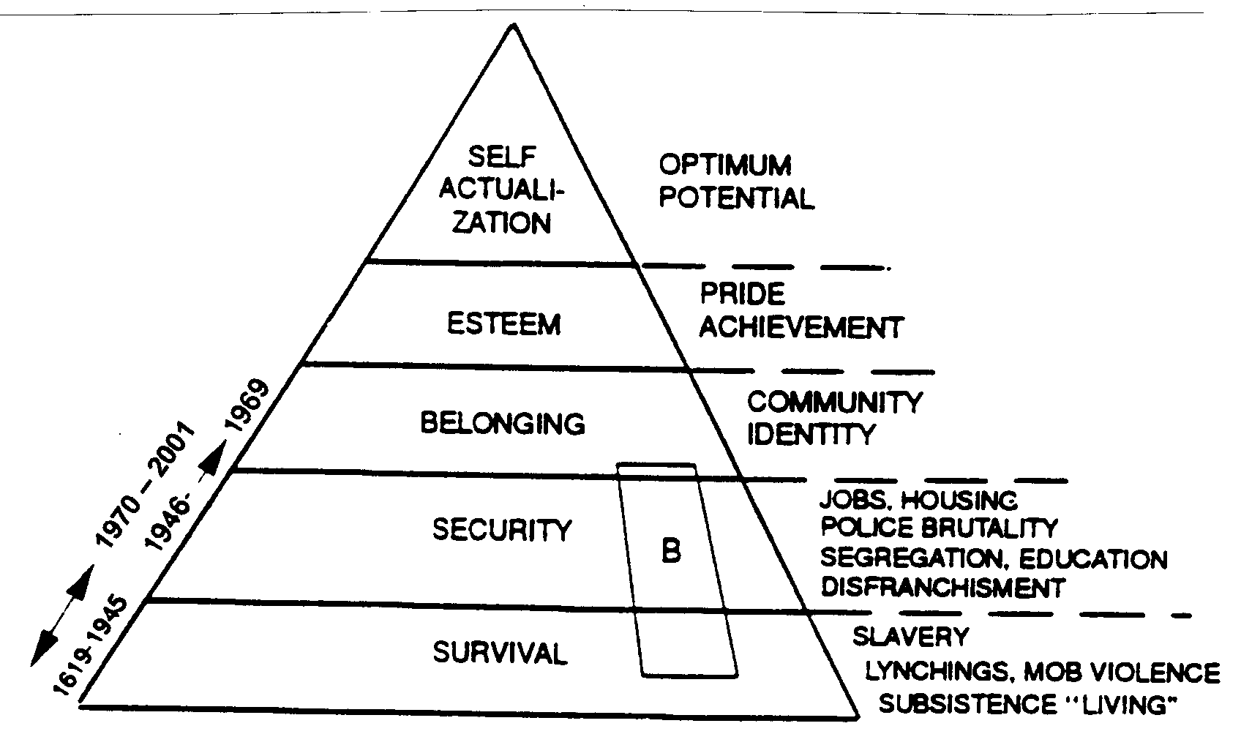

******************************************************************************************

B=Blacks as a group which has attained only marginal "Belonging" in America.
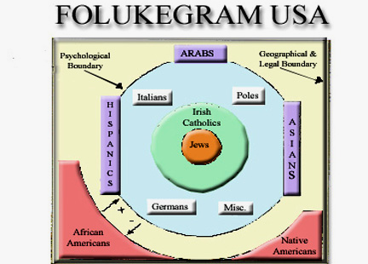
The “Black Group Posture” image above reveals, by definition, the socioeconomic status of Blacks in America as a group, superimposed on Abraham Maslow’s Hierarchy of Human Needs, reflecting that Blacks—again, as a group, have NOT reached the status of “belonging”-acceptance-“community” or authentic psycho-spiritual nationhood in America. The second, “FolukeGram” image above, is an “enlargement” of this same “belonging” level, more closely revealing that Blacks as a group ARE Americans, legally and physically, but NOT Americans psycho-spiritually—creating a dastardly paradox of Black “double consciousness,” as posited by the late Dr. W.E.B. DuBois in The Souls of Black Folks (1903). For this "FolukeGram" is relatively accurate, even in the year 2012 and/or irrespective of the election of President Barack Obama.

***************************************************************************************

Equally germane, in conjunction with allegedly trying to "fix," or "uplift" Black victims, CMS, more seriously, should confront the systemic issue of multi-dimensional White racism--blatant (undisguised), sophisticated (disguised), endemic (subconscious) and institutional (systemic)--and its psycho-social by-product, "kneegroism." To reiterate, I identified these most significant issues to the CMS School Board in 2003--apparently all to no avail, which leads some of us to question whether or not "our" (sic) public schools, sincerely, are interested in EDUCATING Black students, in contrast to "brain-dirtying" them through profuse-recurring propaganda, "his story" or textbook lies and related manipulation of the system. Therefore, whether or not we agree or disagree with the following attached perspectives on this critical issue, let us "listen" to these viewpoints, hopefully with the goal of creating a type of wholistic society, "with liberty and justice for all"--the Pledge that members of this Board take routinely before its periodic meetings.

Final observation: The promoters of the recent, highly funded Project LIFT within CMS--or wherever it is questionably-bureaucratically located--while perhaps well meaning and/or commendable in motive, have not proposed or embraced those type of "different remedies" under "The Polyglot Factor" that we need to create a successful multi-ethnic school system or related authentic community. Therefore, I close with a cautionary, insightful-accurate general statement by Mr. Bill Moyers--presently well-known in public television circles, who once worked for the late President Lyndon Johnson--to wit: "America Can't Deal With Reality -- We Must Be Exposed to the Truth, Even If It Hurts. Many people inhabit a closed belief system on whose door they have hung the 'Do Not Disturb' sign."

Bottom line, it is FAR past time for all of us to more seriously address--head-on and devoid of political fear--this protracted "race" issue that has and continues to plague us. For it will not go away by ignoring or further attempting to finesse it, "the Charlotte way," the latter which is good, but not good enough for our present crisis. And I thank you for your attention and, hopefully, for your positive response to these proposals. Hotep (Peace)! May the Peace of our Creator be unto all of us--as and if we seek to build the Kingdom of God, "on earth, as in Heaven!" Amen!
*************************************************************************************
SEVEN DIMENSION OF FREEDOM
- Physical Mental
- Economic Cultural
- Political Emotional
- Spiritual
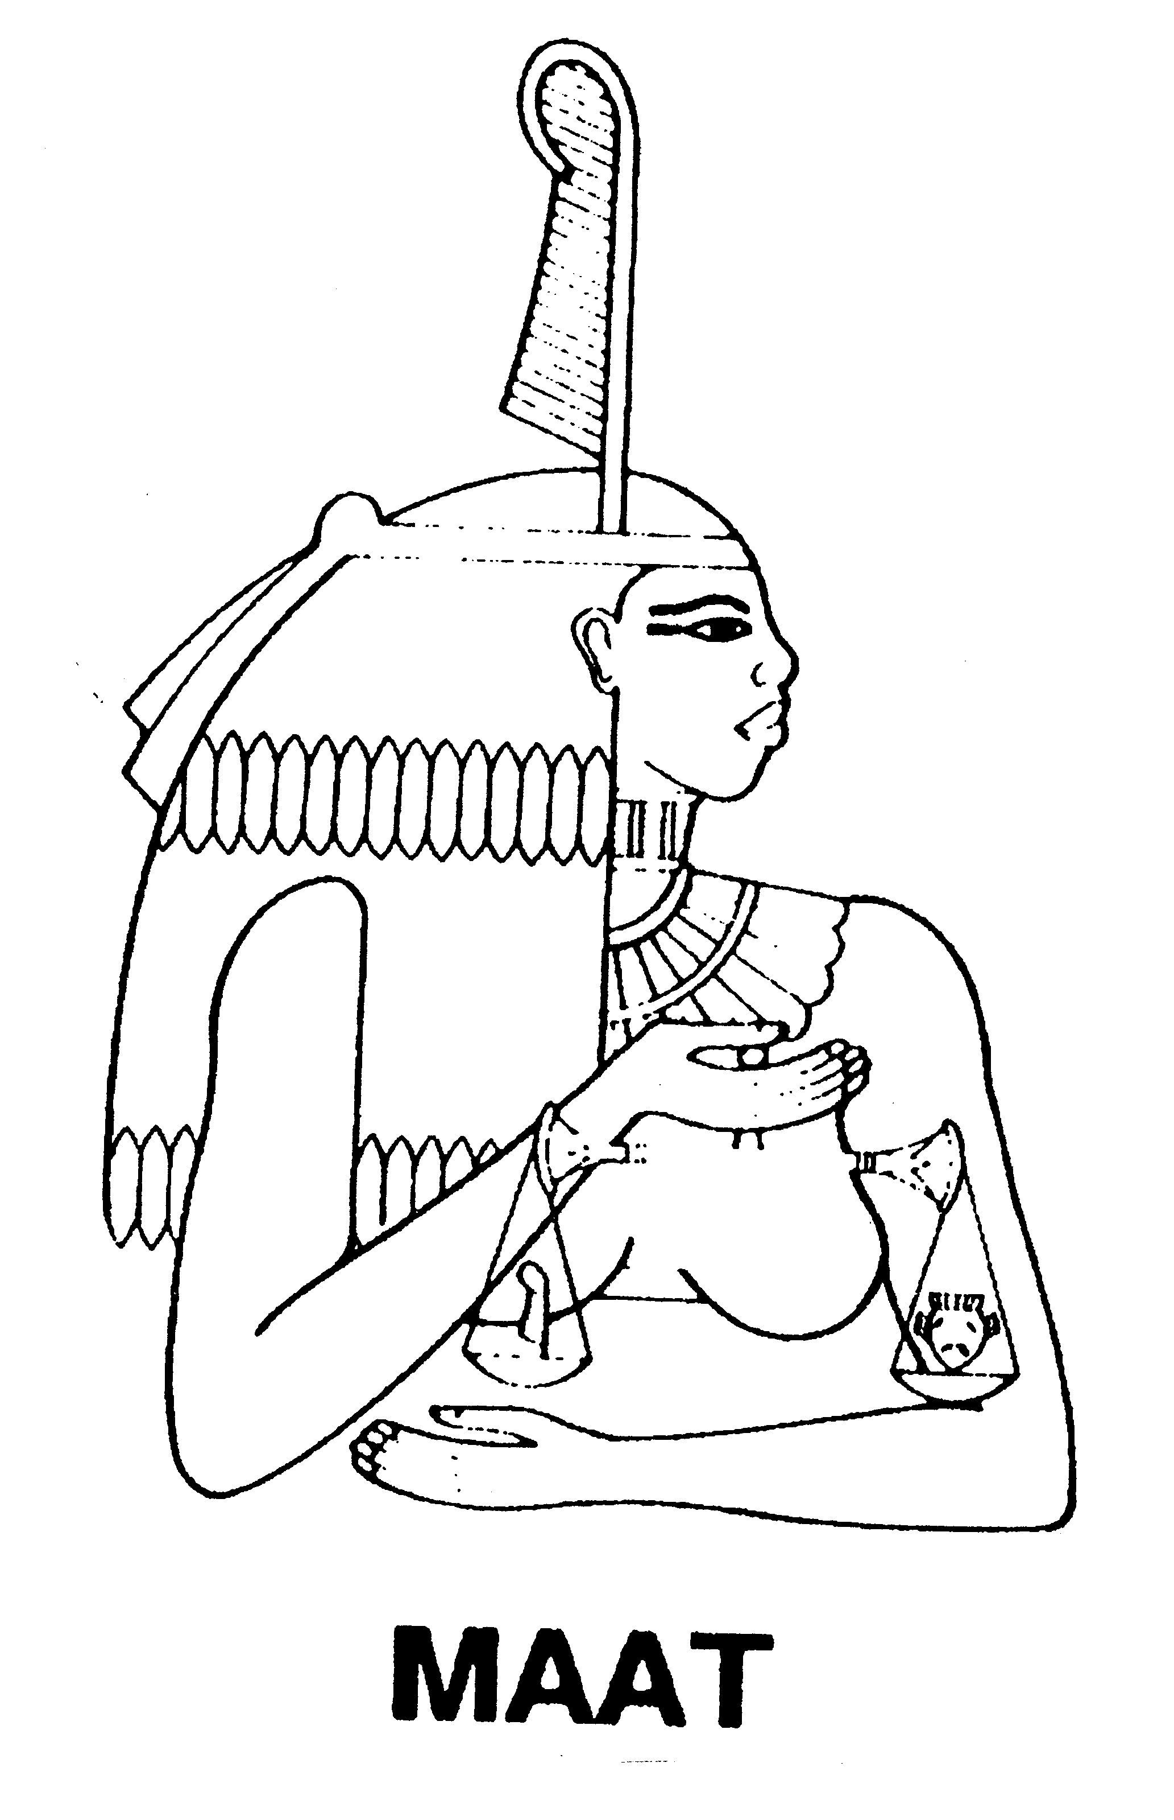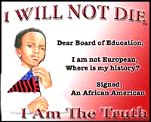
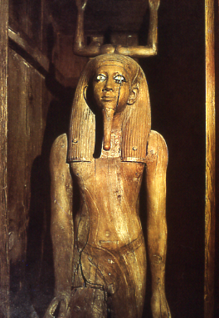
The "Ka," ancient Kemetic (Egyptian) symbol revealing beliefs in spiritual aspects of generic man that lives after "death" of the physical body. Therefore, we may kill the physical body or messenger of truth, but not the of Truth. As stated by that great slave abolitionist, William C. Bryant, "Truth, crushed to the ground, will rise again." Amen!
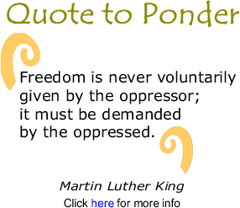

*************************************************************************************
Attachments
1. New book Cover, Overview, Contents and Author's Vita
2 Relevant Quotations & Commentary For Reflection .
*"Kneegroes"--those Blacks who embrace, or fail to challenge the system of White supremacy-racism, metaphorically, those who are content to remain on their knees as impediments to Black progress on a group or individual level. Reference: The Scoundrel Syndrome, (Foluke, 2004)

